**Lab 3**

1. Display your MAC address by 2 different ways.

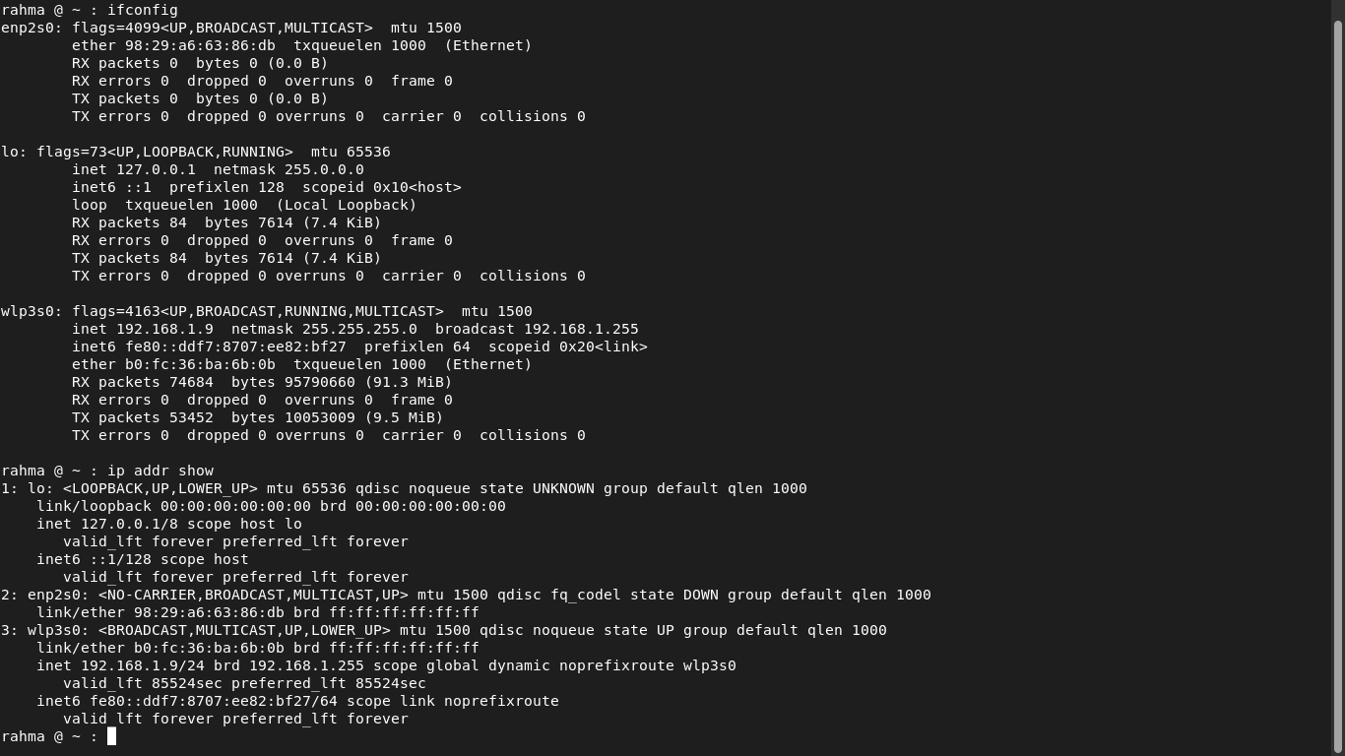

2. Display the network settings of all active interfaces.

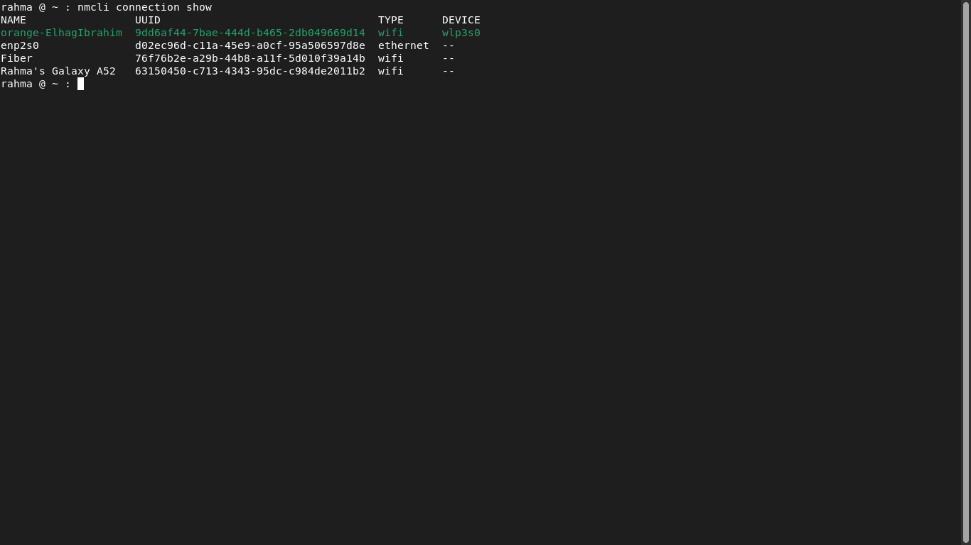

3. Display the network setting of all interfaces both active inactive.

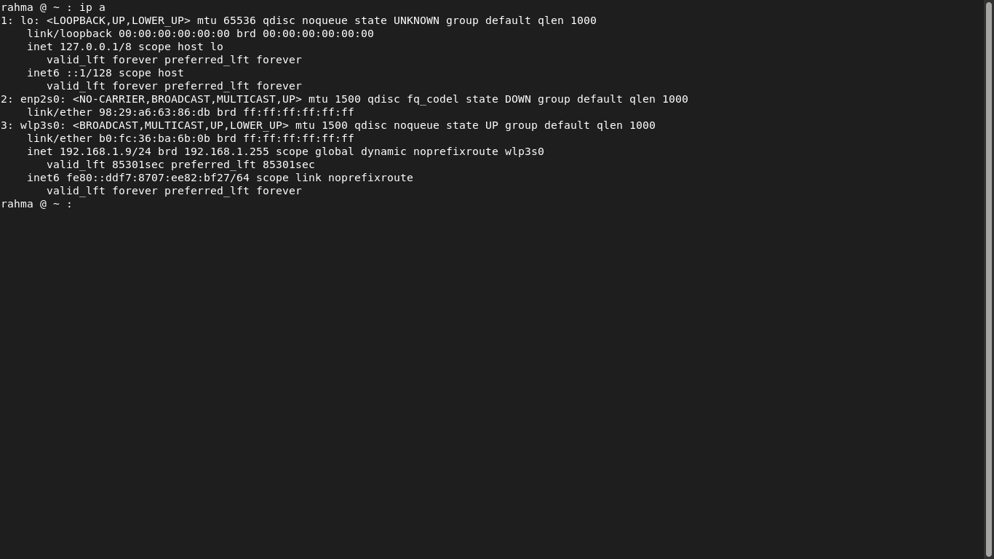

4. Bring your interface down.

sudo ifconfig wlo1 down

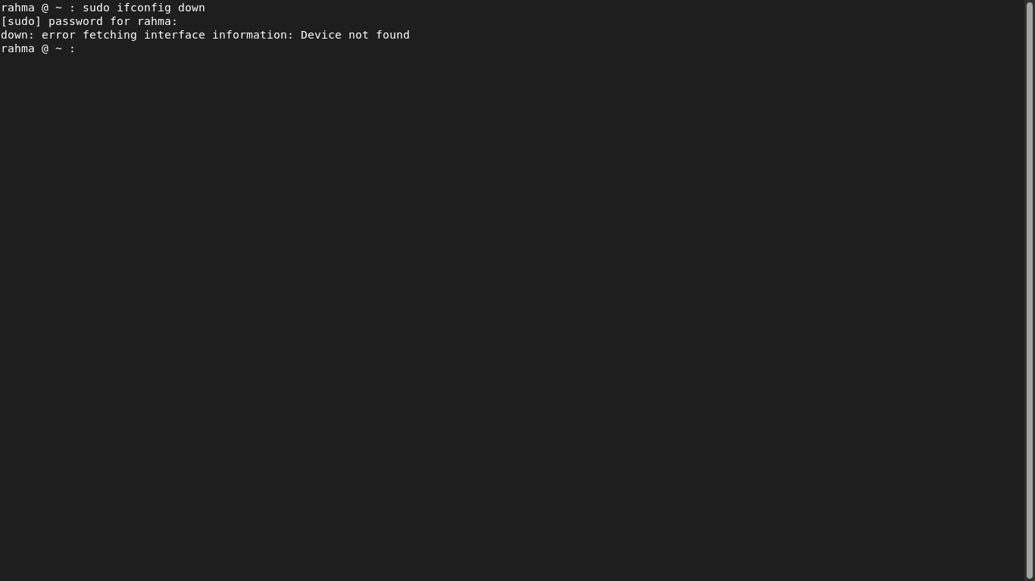

5. Configure your network card to have static IP.

sudo ifconfig wlo1 192.168.1.10 netmask 255.255.255.

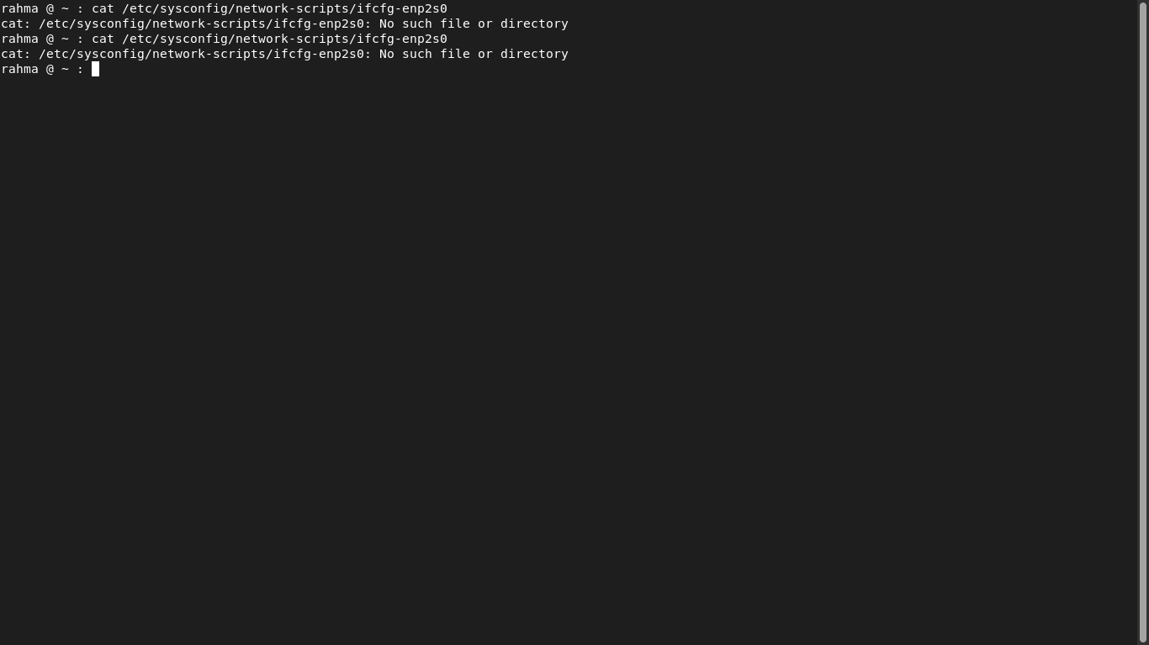

6. Bring your interface up.

* DEVICE=eth0
* BOOTPROTO=none
* ONBOOT=yes
* PREFIX=24
* IPADDR=192.168.2.203

sudo ifconfig wlo1 up

7. Verify your network setting using ifconfig command

systemctl restart NetworkManager

ifconfig

8. Configure your network card to have dynamic IP using network

manager command.

ip link set dev eth0 up

sudo ifconfig wlo1 up

9. Check using ifconfig then check its configuration file.

sudo ifconfig wlo1 up

ifconfig

10. Reconfigure your network card using system-config-network

utility to have static IP.

11. Configure your network card to have 3 IPs and check that they

are all working using ifconfig command.

12. Change your host name in your global network file.

sudo gedit /etc/syscongig/network

13. Check the present value of /proc/sys/net/ipv4/icmp_echo_ignore_all

sudo */proc/sys/net/ipv4/icmp_echo_ignore_all*

14. It should be 0, change it to 1 which will prevent other hosts from successfully pinging your host

sudo gedit */proc/sys/net/ipv4/icmp_echo_ignore_all*

while not affecting your ability to ping them.

15. Try to ping your colleague, let your colleague try to ping your host.

Ping from me to others works, and NOT vice versa.

16. Reboot and try the last step. What happened? Why?

17. Edit /etc/sysctl.conf and put the following line at the bottom:

net.ipv4.icmp_echo_ignore_all=1

18. Execute sysctl –p command.

19. Check the value of /proc/sys/net/ipv4/icmp_echo_ignore_all.

Using yum

20. Attempt to run the command gnuplot. You should find that it is not

installed.

21. Search for the plotting packages.

22. Find out more information about the gunuplot package.

23. Install the gnuplot package.

24. Attempt to remove the gnuplot package, but say no

How many packages would be removed

25. Attempt to remove the gunplot-common package but say no

How many packages would be removed

Using rpm

26. List all installed packages in your system.

27. View the files in the initscripts package

28. Get general information about bash rpm.

29. Have the files from the pam package changed since it was

installed.

30. Which installed packages have gnome in their names?

31. Install any uninstalled package from RH Enterprise Linux cds

32. Search for software resemble the Photoshop software other than

Gimp and install it.

33. Create the file /etc/yum.repos.d/cdrom.repo to enable install from

the iso from the iso of Red Hat.

34. Try to install any package from the new repository